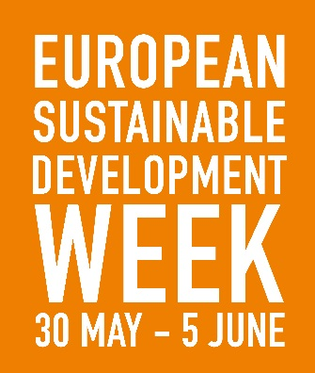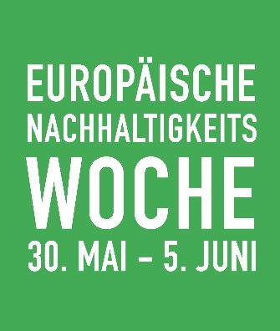
SUPPORTED BY THE EUROPEAN SUSTAINABLE DEVELOPMENT NETWORK

The European Sustainable Development Week (ESDW) is a European-wide initiative to stimulate and make visible activities, projects, and events that promote sustainable development. Building on last year’s success of 4,212 activities in 38 countries, it will take place from 30 May – 5 June 2017.
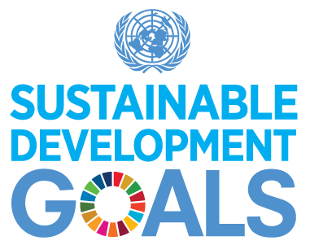
The ESDW 2017 will link to the Sustainable Development Goals.

- START NOW!
Think about how you could promote sustainable development and plan an activity, project or event to take place during the ESDW.

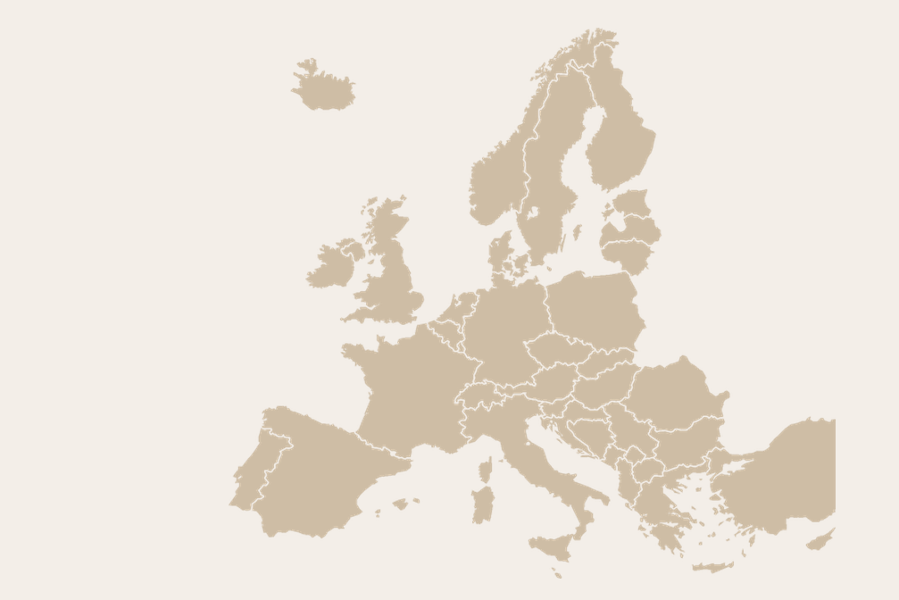
3. ACT!
Organize and promote your initiative during the ESDW 30 May – 5 June 2017! Explore which events are taking place in Europe and participate in activities near you!

REGISTRATION will be open to government agencies, research centers, educational institutions, museums, foundations, associations, and businesses, as well as individual citizens if the proposed event/project promotes sustainable development and contributes to the SDGs.
CONTACT:
Website: www.esdw.eu
Facebook: EuropeanSustainableDevelopmentWeek
Twitter: @EuropeanSDWeek

2. REGISTER!
Upload your idea on the ESDW website!

