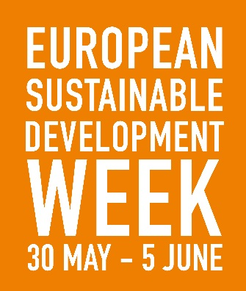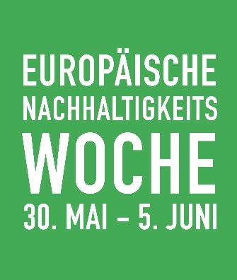
SUPPORTED BY THE EUROPEAN SUSTAINABLE DEVELOPMENT NETWORK

The European Sustainable Development Week (ESDW) is a European-wide initiative to stimulate and make visible activities, projects, and events that promote sustainable development. Building on last year’s success of 4,212 activities in 38 countries, it will take place from 30 May – 5 June 2017.
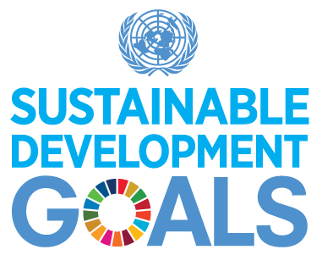

OUR INITIATIVE:

CONTACT:
Website: www.esdw.eu
Facebook: EuropeanSustainableDevelopmentWeek
Twitter: @EuropeanSDWeek

